COVID-19 NOTICE
SAFETY UPDATE – Please Stop and Read

Visitor Center Open with Capacity Limits

In order to accommodate social distancing, this Visitor Center allows up to (2/4/6-fill in limit) visitors inside at one time. Please check before entering.
Please wait outside if the number of visitors inside exceeds the capacity limit.
While in the VC/Club House/Museum – fill in blank, Park Staff ask all visitors to:
- Maintain a 6’ social distance between all visitors and staff.
- Visitors are encouraged to wash hands and/or use hand sanitizer frequently.
- Visitors are encouraged to wear cloth face coverings in all public settings.

For the latest updates on park status visit: gastateparks.org/Alerts

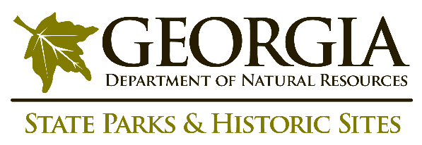
The safety and welfare of staff and the public is a top priority for the Georgia Department of Natural Resources, as we continue to monitor COVID-19 guidance from the Center for Disease Control and Prevention.
FOR IMMEDIATE EMERGENCY ASSISTANCE PLEASE DIAL 911

